**Goal:** Tolearn how to build network topology using Mininet Python APIs and how to assign parameters like bandwidth and delay for different links in the topology. You’ll also learn how to do performance testing of topology using ping and iperf tools.

1. **Create mininet topology script for the network topology given below**

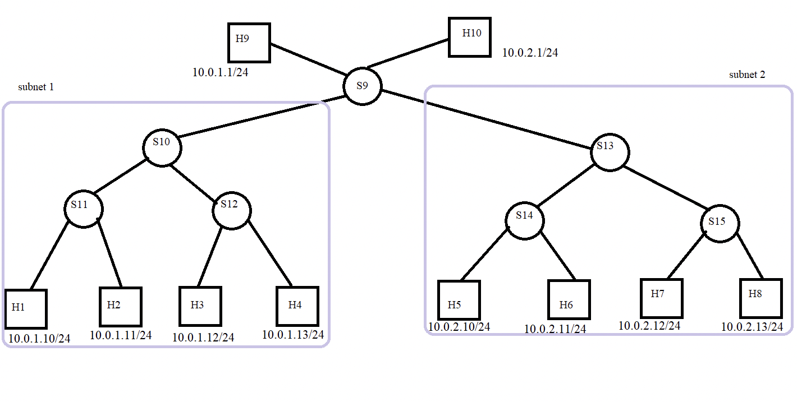

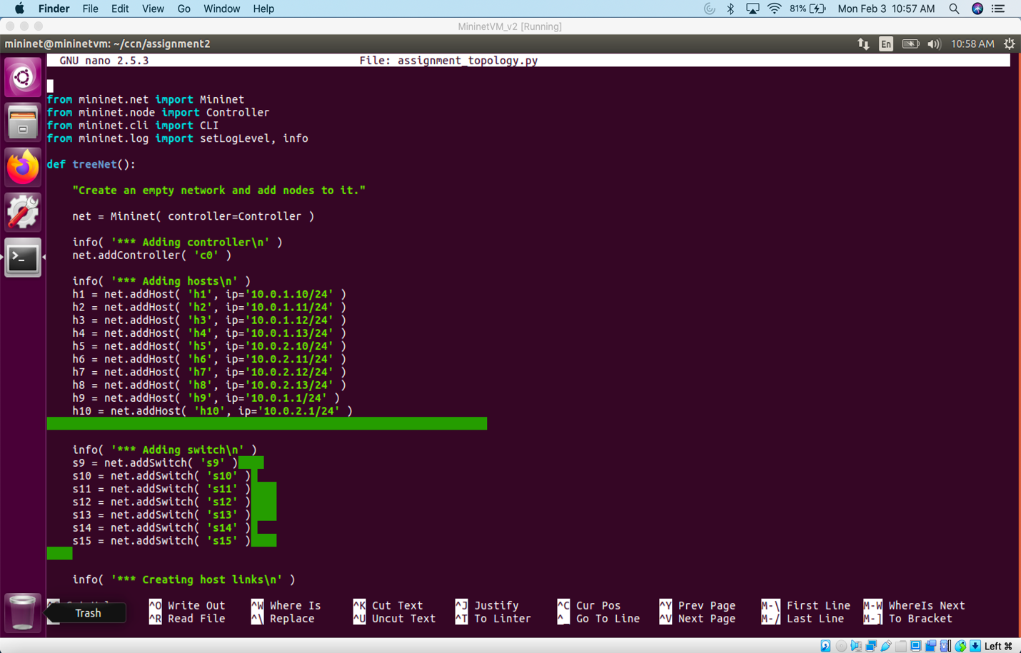

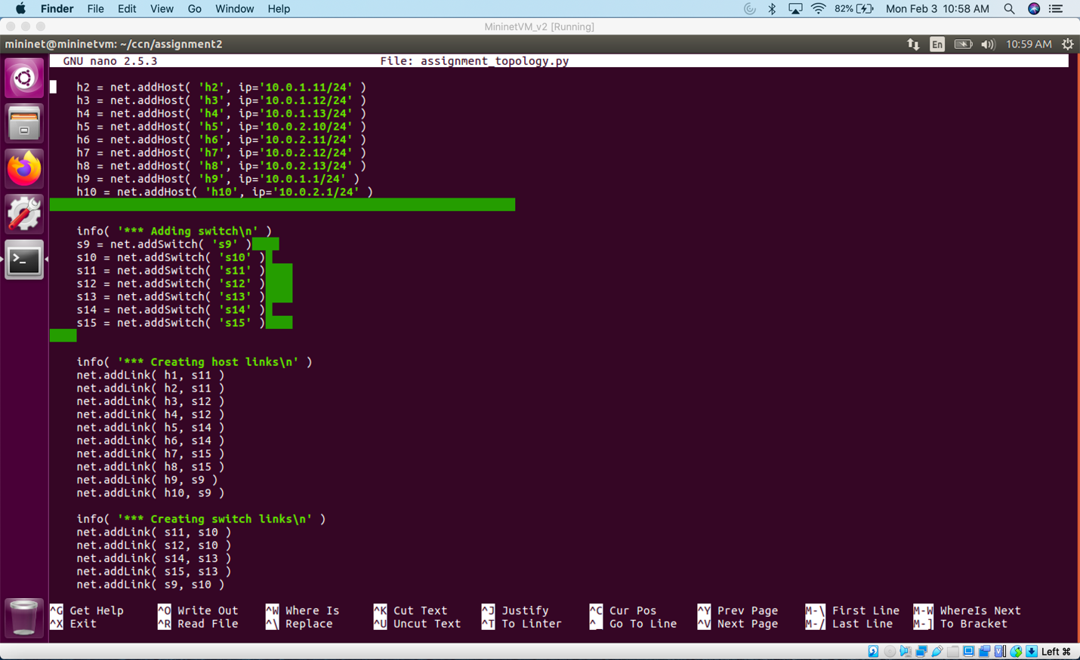

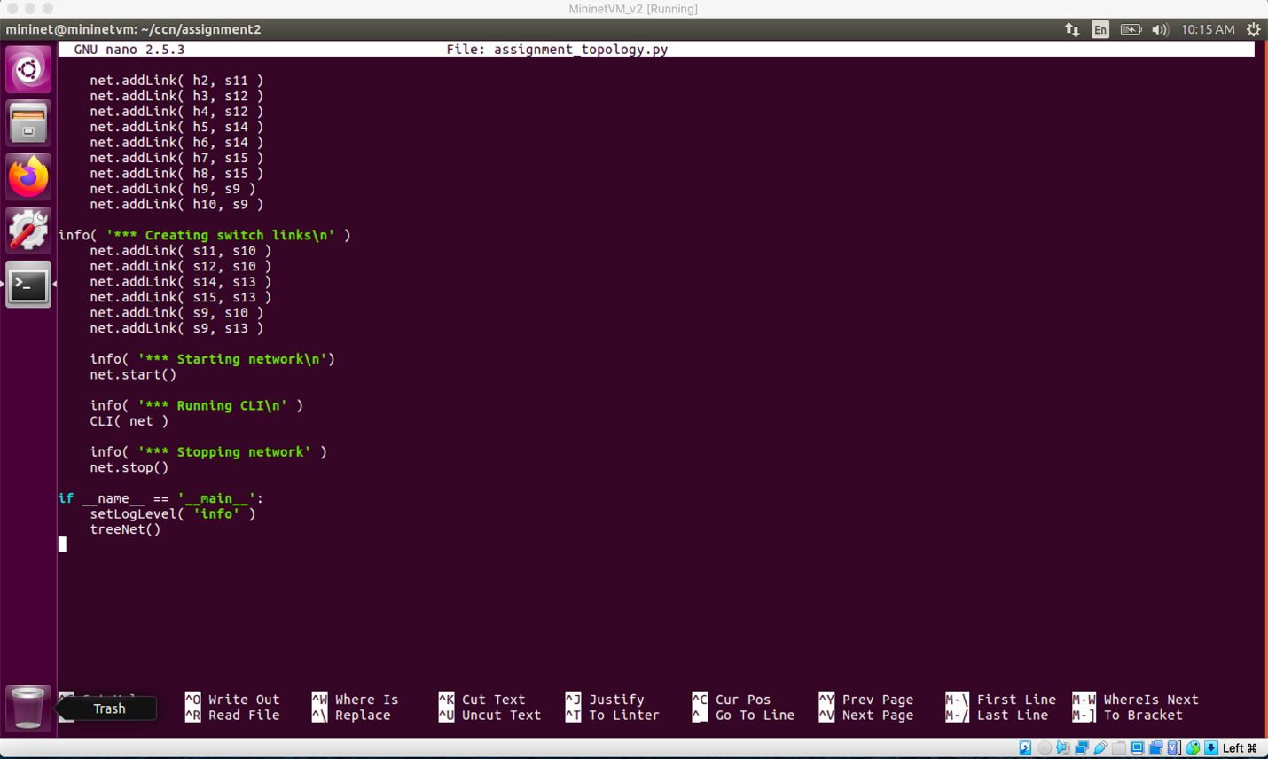

1. **Run the topology script in the provided VM as shown below**

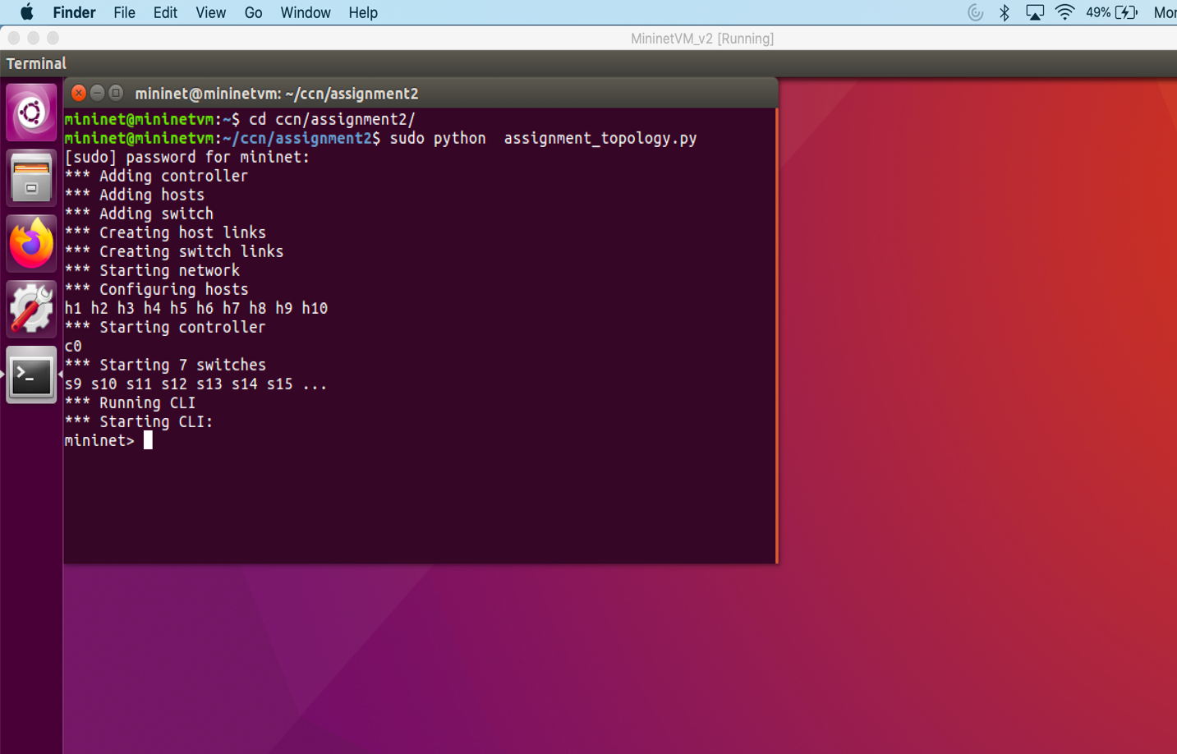

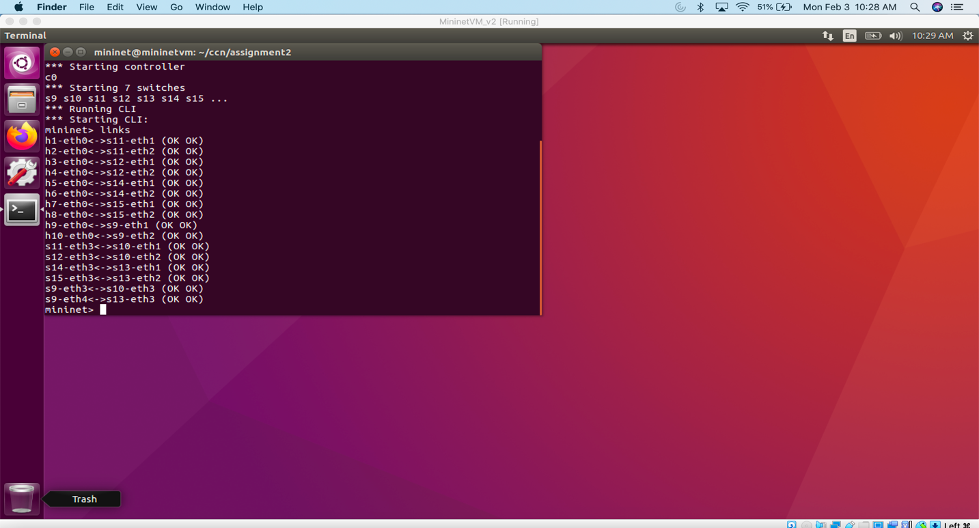

1. **Use ping all command in mininet terminal and check the connectivity**

The host h9 network is 10.0.1.1 and network of h10 is 10.0.2.1. Both h9 and h10 belong to different network. H1, h2, h3, h4, h9 are connected to the same network and h10, h5, h6, h7, h8 are connected to the same network but both the network grp differs from each other. They are configured using subnet mask 255.255.255.0. since there are no routers these two networks cannot communicate with each other.

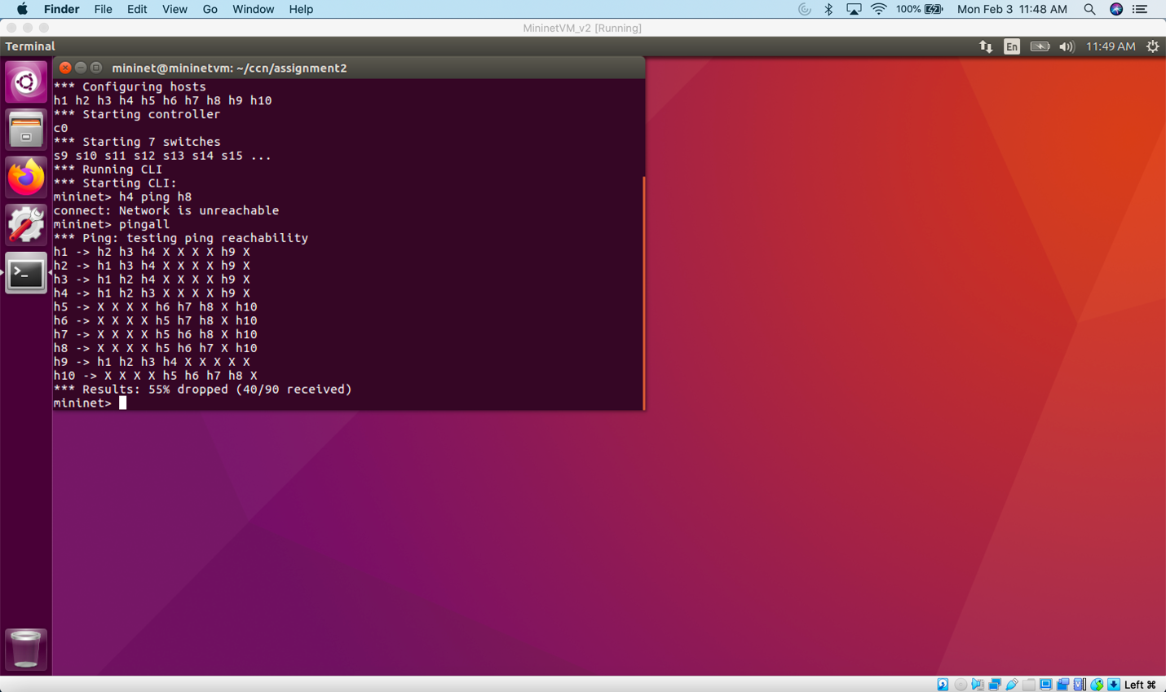

1. **analyzing the network topology**

|  |  |  |  |  |  |
| --- | --- | --- | --- | --- | --- |
| Host | IP address | Is this host pingable from h9? | Is this host pingable from h10? | Measure bw and delay using iperf on h9 | Measure bw and delay using iperf on h10 |
| H1 | 10.0.1.10/24 | Yes | No | 11.5 Mbits/sec | Network not reachable |
| H2 | 10.0.1.11/24 | Yes | No | 11.5 Mbits/sec | Network not reachable |
| H3 | 10.0.1.12/24 | Yes | No | 11.5 Mbits/sec | Network not reachable |
| H4 | 10.0.1.13/24 | Yes | No | 11.6 Mbits/sec | Network not reachable |
| H5 | 10.0.2.10/24 | No | Yes | Network not reachable | 39.4 Gbits/sec |
| H6 | 10.0.2.11/24 | No | Yes | Network not reachable | 28.8 Gbits/sec |
| H7 | 10.0.2.12/24 | No | Yes | Network not reachable | 30.0 Gbits/sec |
| H8 | 10.0.2.13/24 | No | Yes | Network not reachable | 37.5 Gbits/sec |
| H9 | 10.0.1.1/24 | Yes | No | 9.55 Mbits/sec | Network not reachable |
| H10 | 10.0.2.1/24 | No | Yes | Network not reachable | 39.1 Gbits/sec |

**Scenario 1**

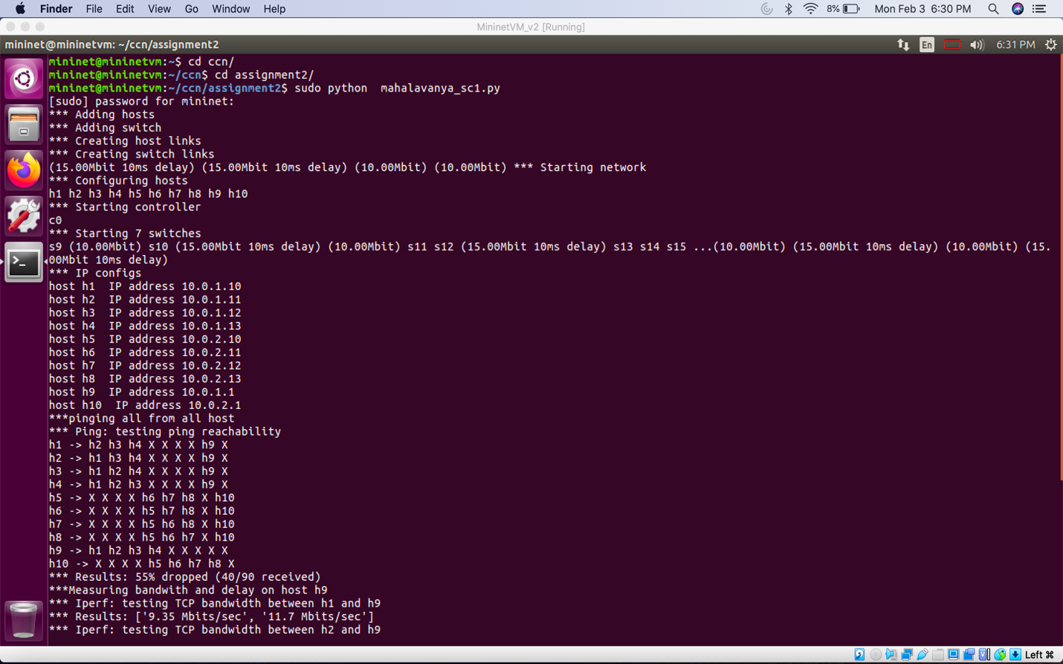

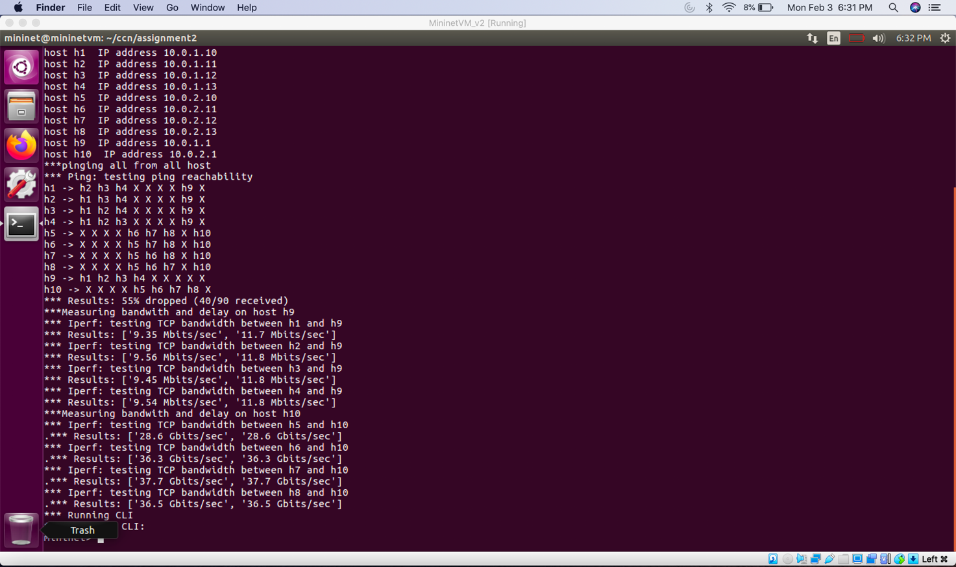

**Measure of Bandwidth and Delay (h1, h2 … h10 on h9)**

**Delay Calculation**

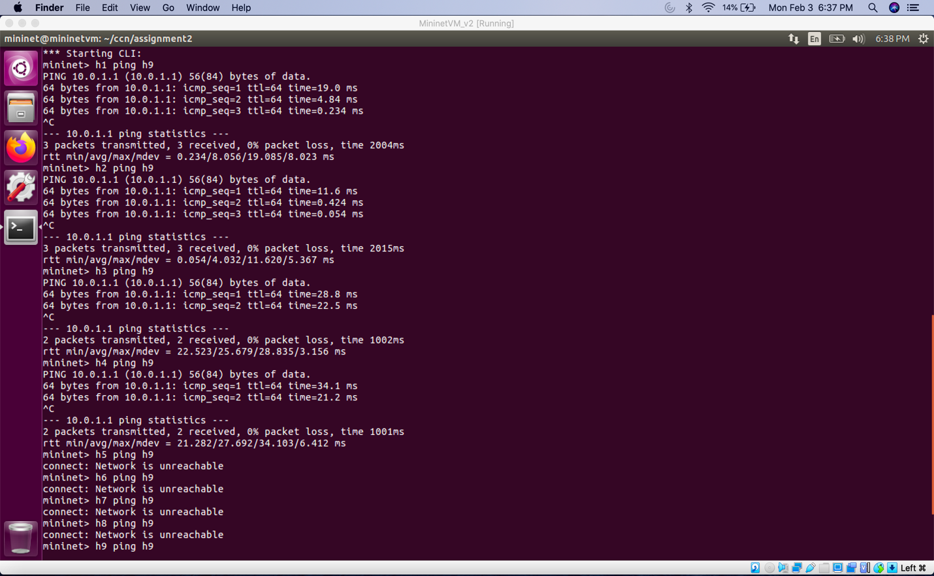

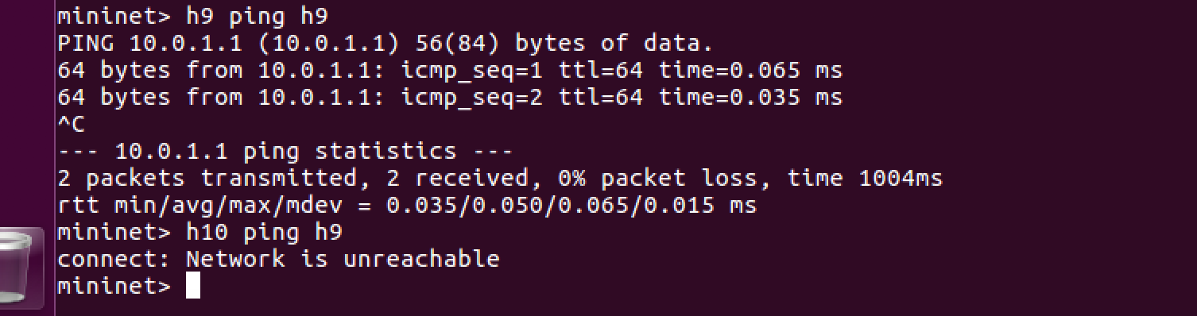

**Bandwidth**

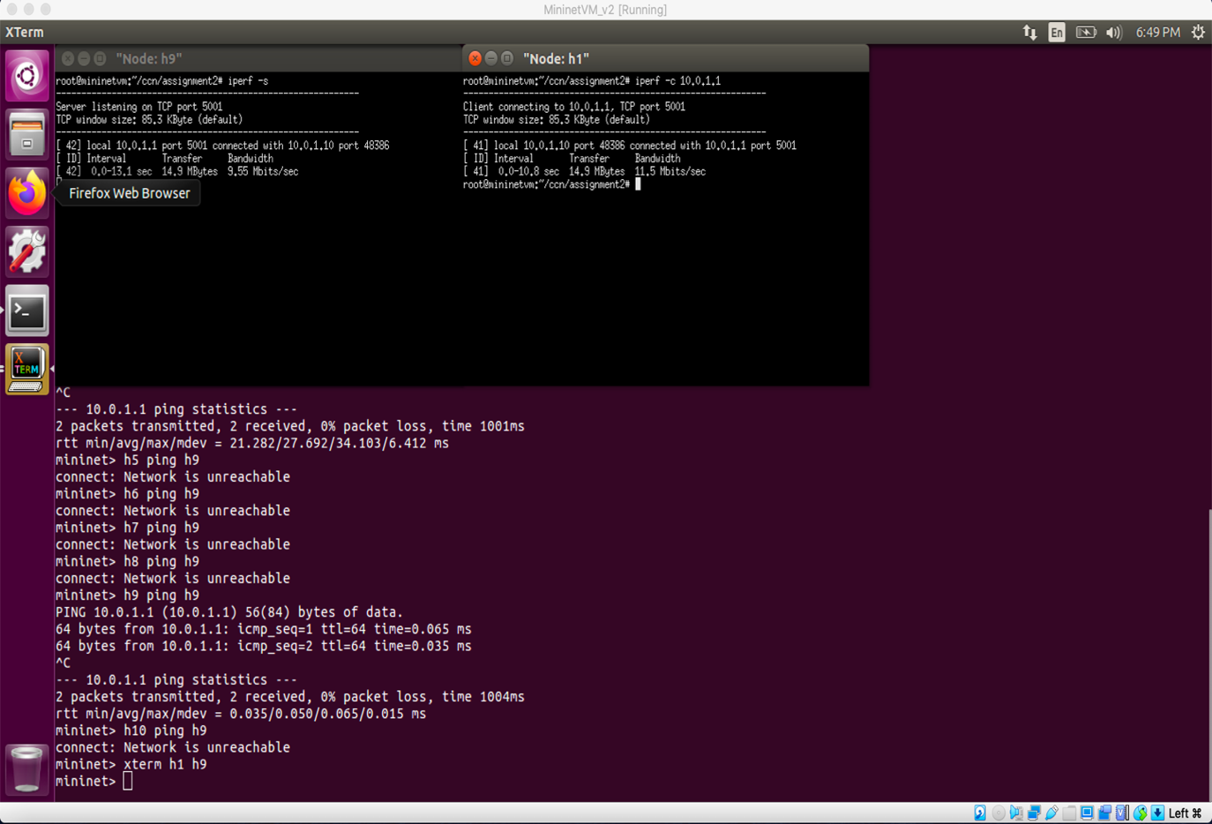

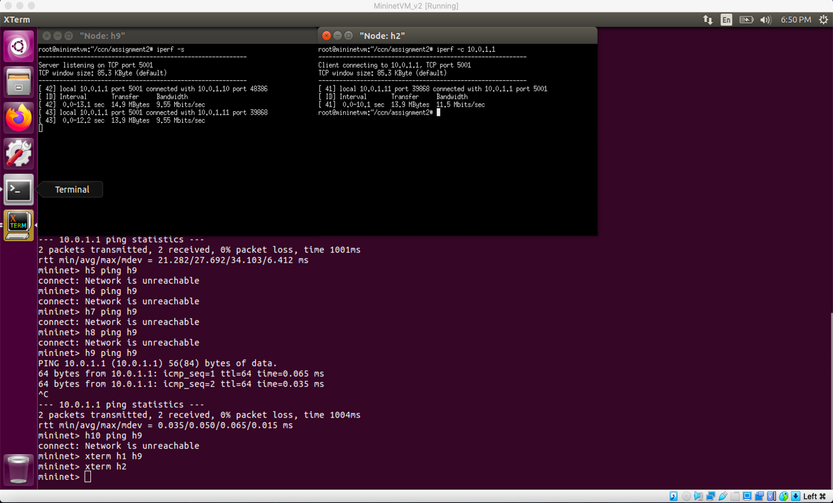

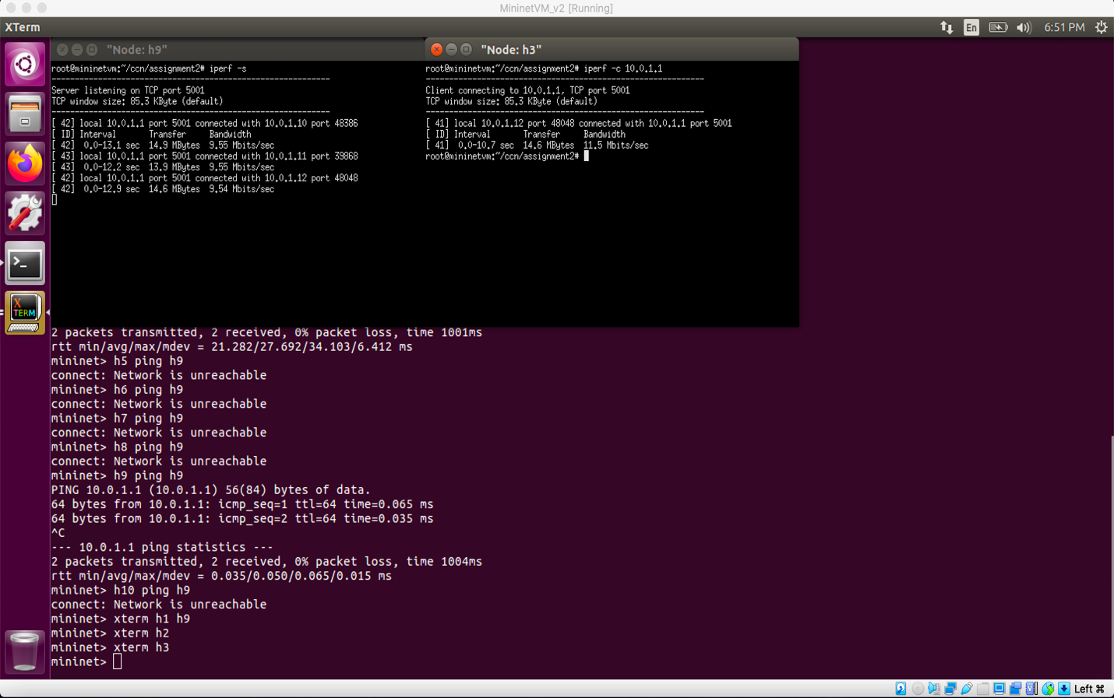

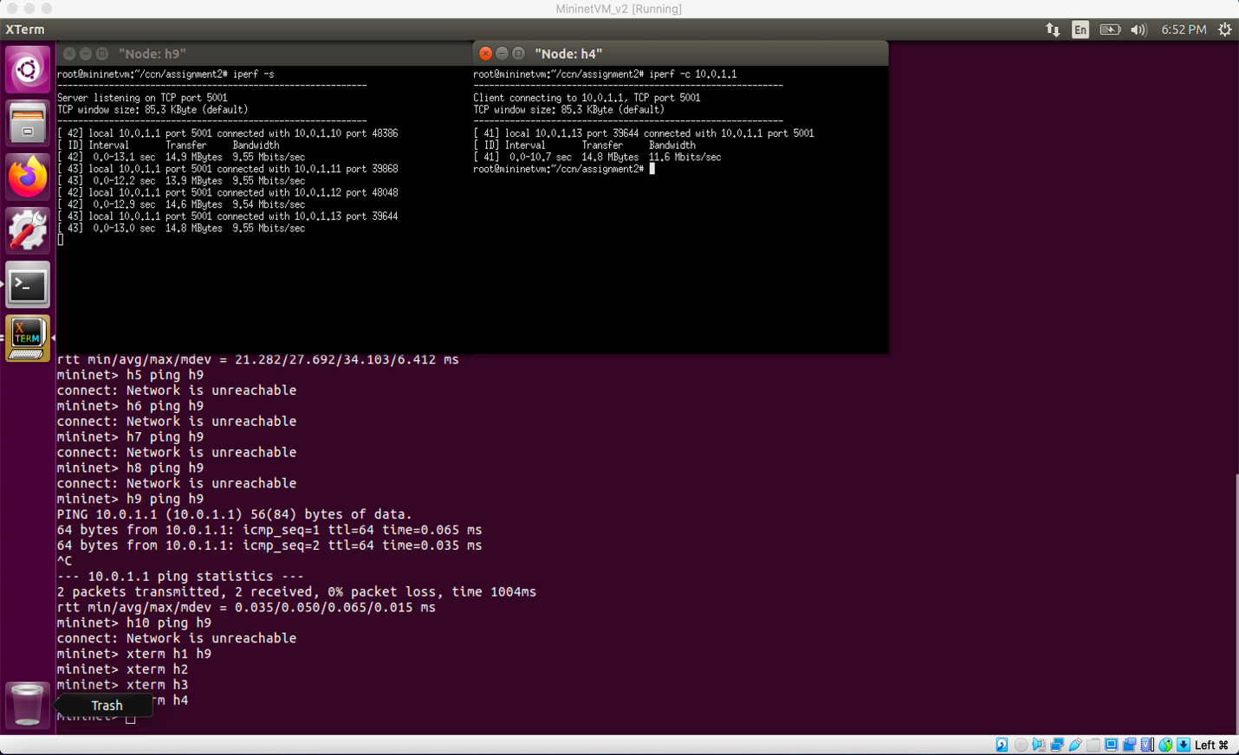

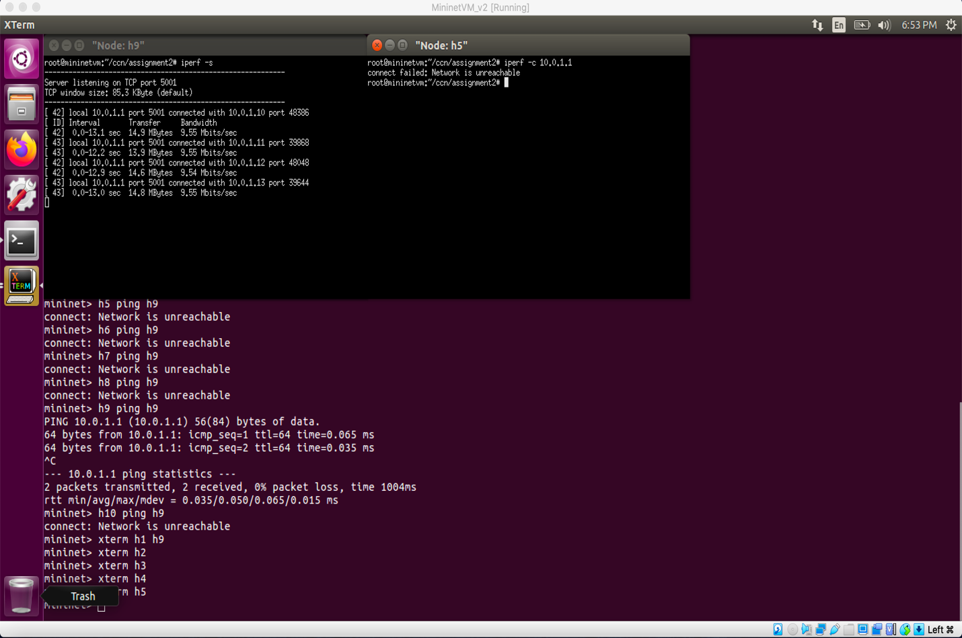

**Measure of Bandwidth and Delay (h1, h2 … h10 on h10)**

**Delay Calculation**

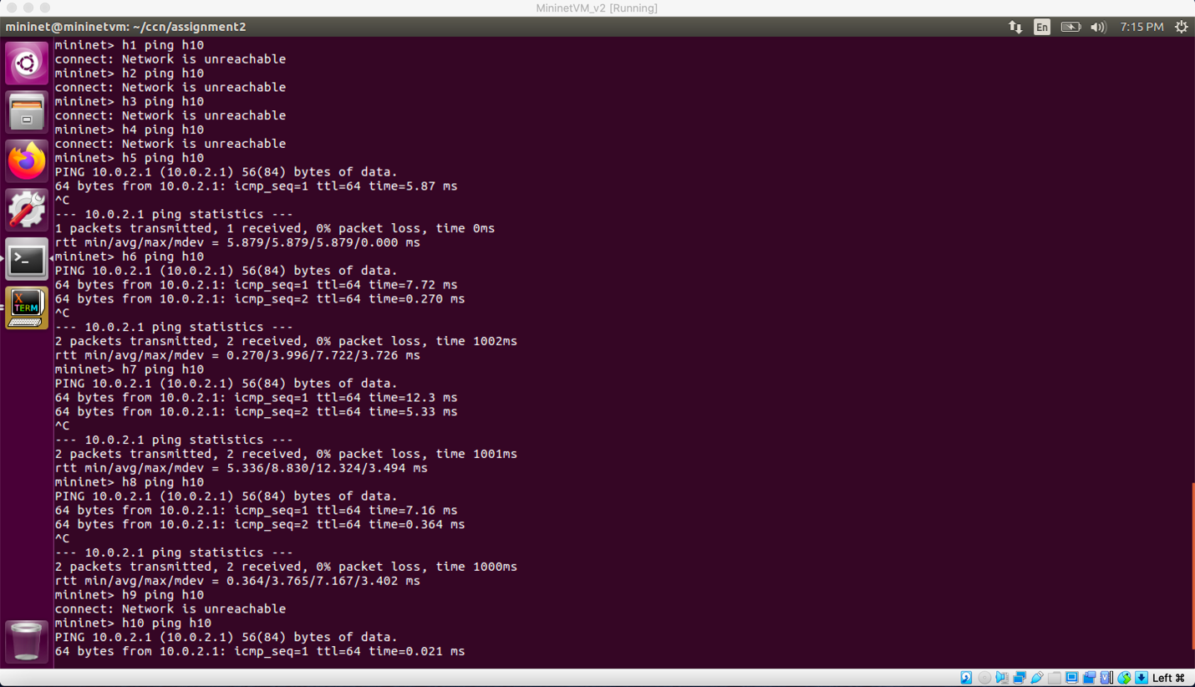

**Bandwidth**

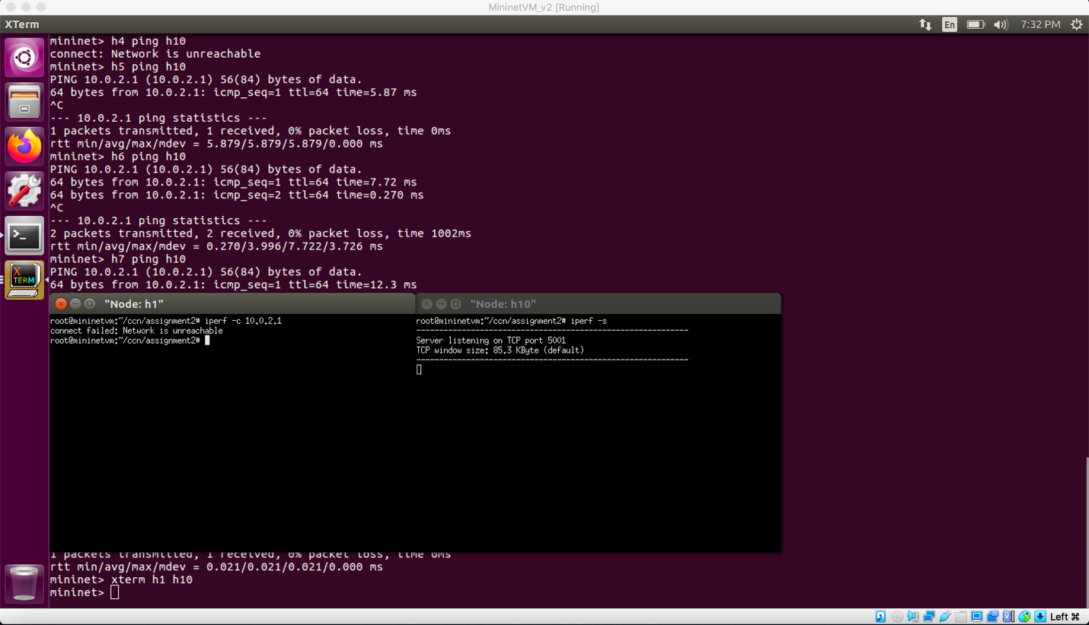

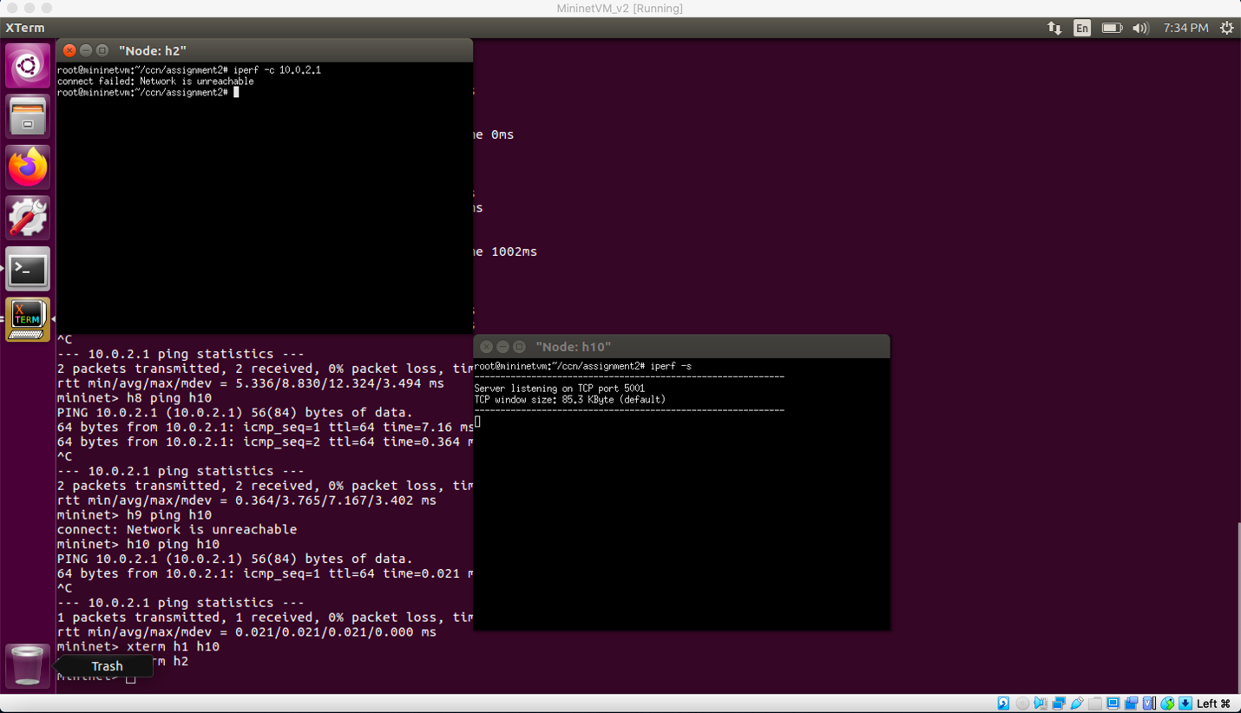

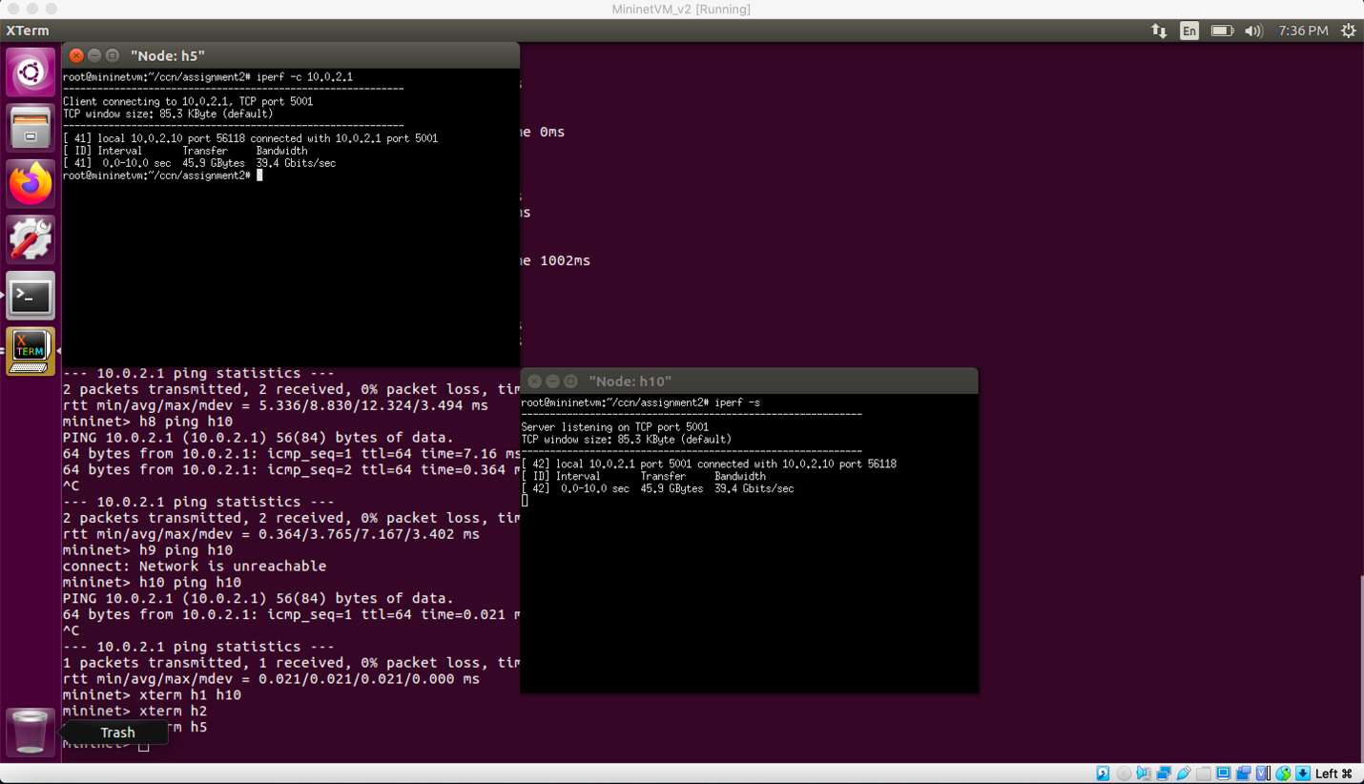

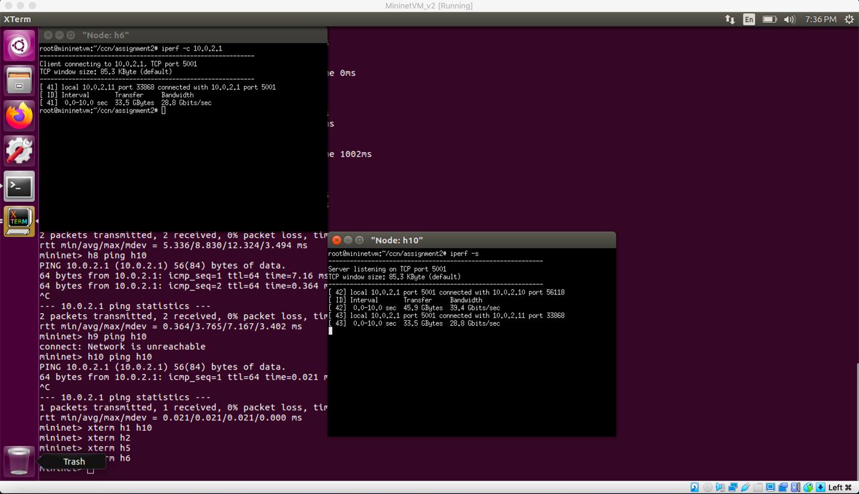

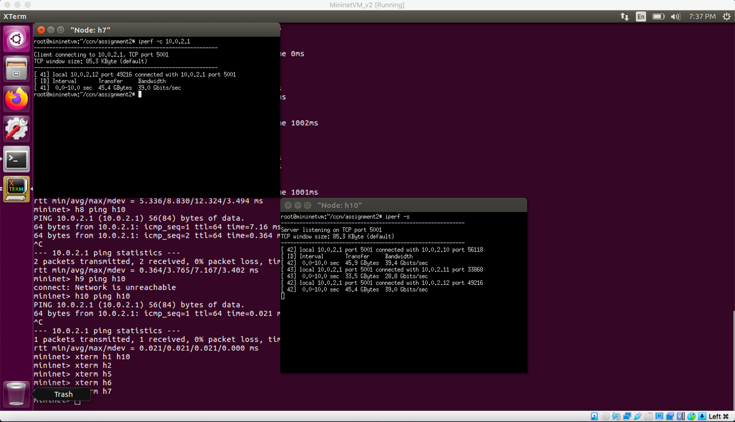

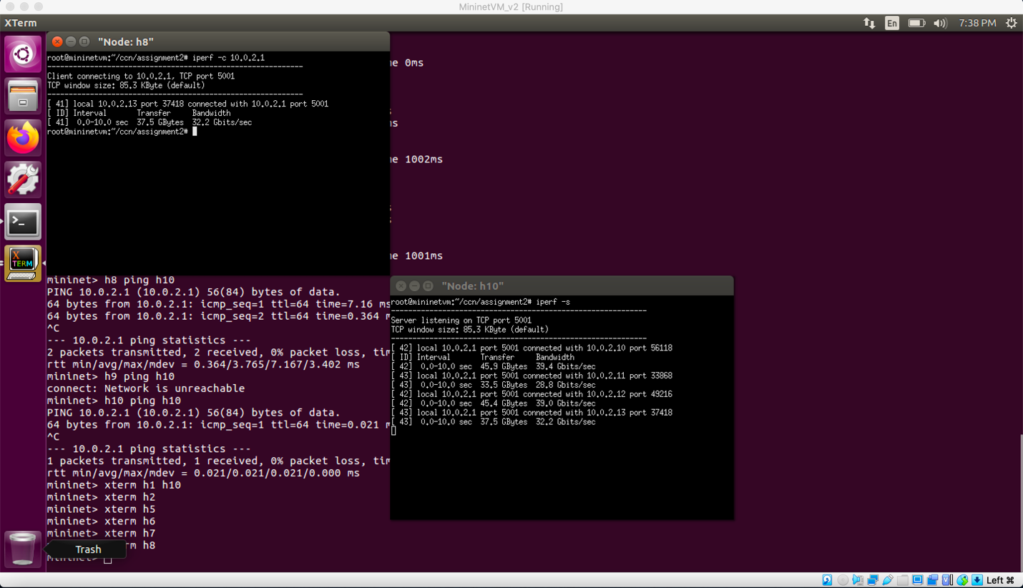

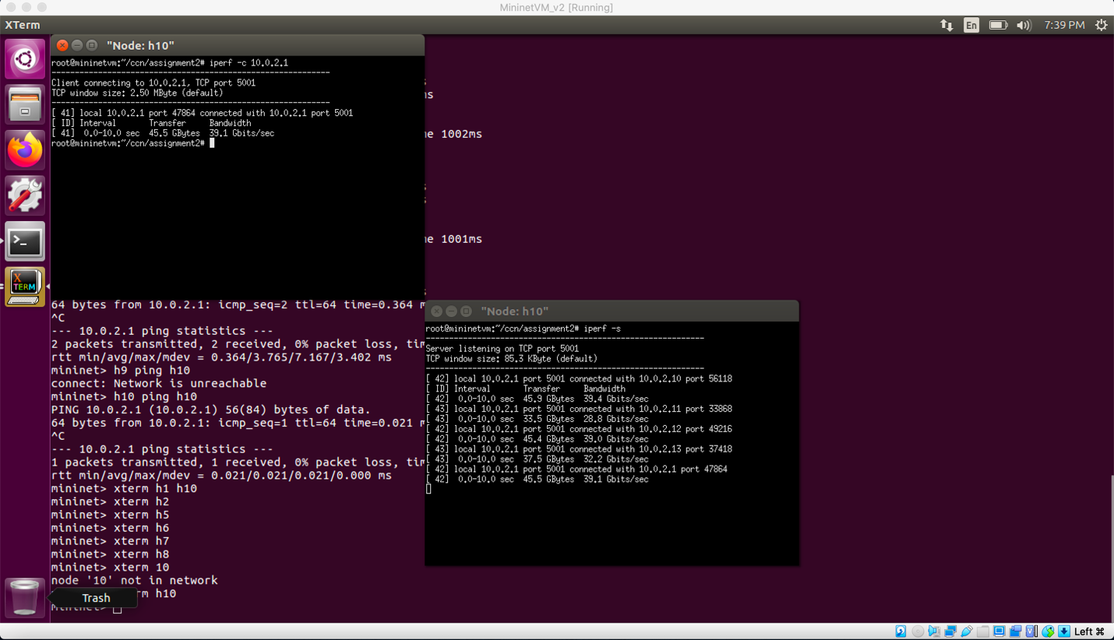

**Scenario 2**

|  |  |  |  |  |  |
| --- | --- | --- | --- | --- | --- |
| Host | IP address | Is this host pingable from h9? | Is this host pingable from h10? | Measure bw and delay using iperf on h9 | Measure bw and delay using iperf on h10 |
| H1 | 10.0.1.10/24 | Yes | No | 35.6 Gbits/sec | Network not reachable |
| H2 | 10.0.1.11/24 | Yes | No | 29 Gbits/sec | Network not reachable |
| H3 | 10.0.1.12/24 | Yes | No | 38.6 Gbits/sec | Network not reachable |
| H4 | 10.0.1.13/24 | Yes | No | 30.1 Gbits/sec | Network not reachable |
| H5 | 10.0.2.10/24 | No | Yes | Network not reachable | 22.9 Mbits/sec |
| H6 | 10.0.2.11/24 | No | Yes | Network not reachable | 22.7 Mbits/sec |
| H7 | 10.0.2.12/24 | No | Yes | Network not reachable | 20.0 Mbits/sec |
| H8 | 10.0.2.13/24 | No | Yes | Network not reachable | 22.6 Mbits/sec |
| H9 | 10.0.1.1/24 | Yes | No | 40.2 Gbits/sec | Network not reachable |
| H10 | 10.0.2.1/24 | No | Yes | Network not reachable | 40.1 Gbits/sec |
|  |  |  |  |  |  |

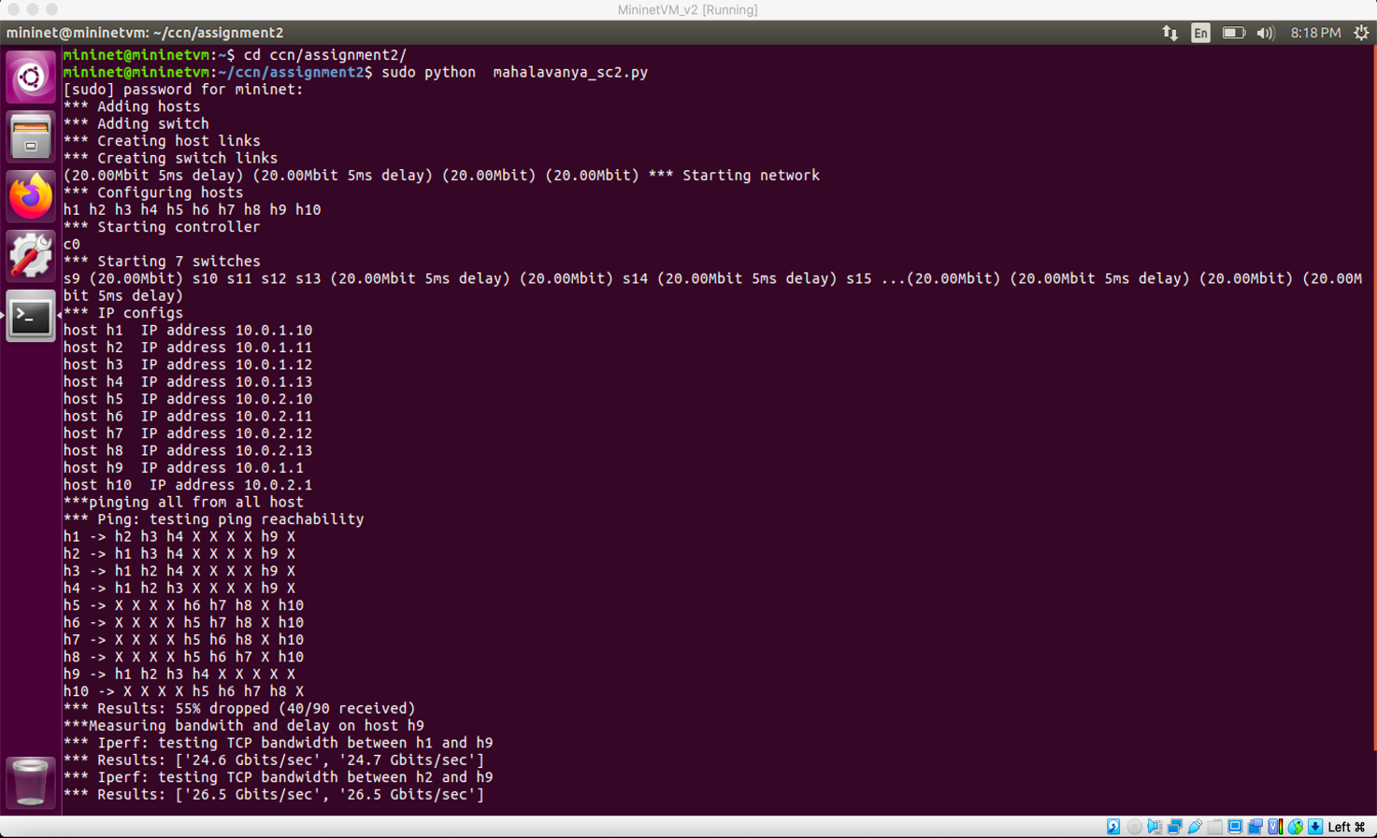

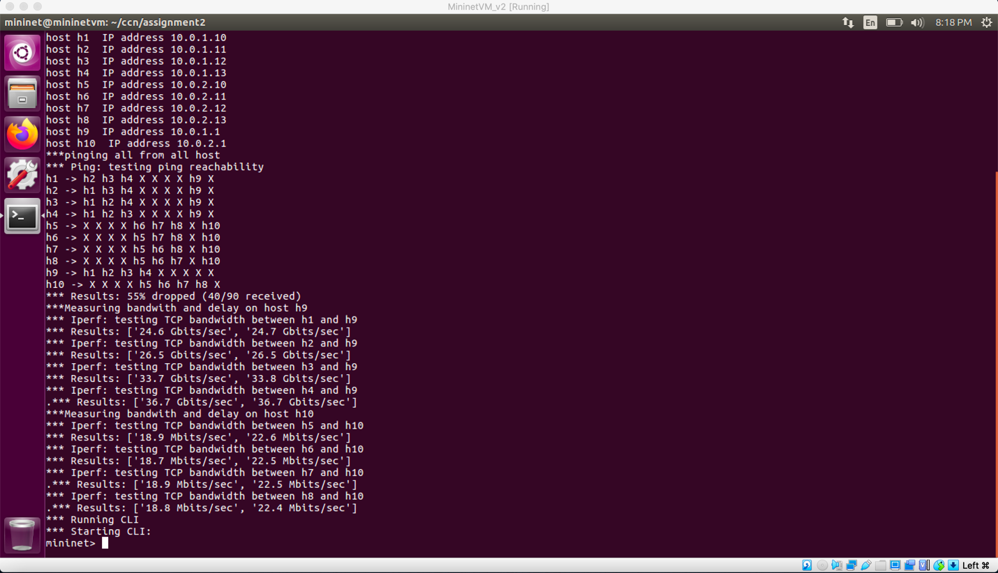

**Measure of Bandwidth and Delay (h1, h2 … h10 on h9)**

**Delay Calculation**

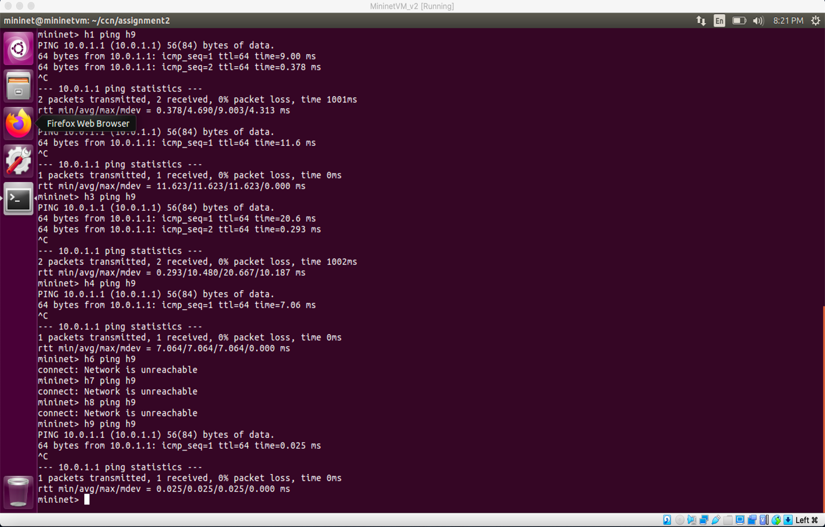

**Bandwidth**

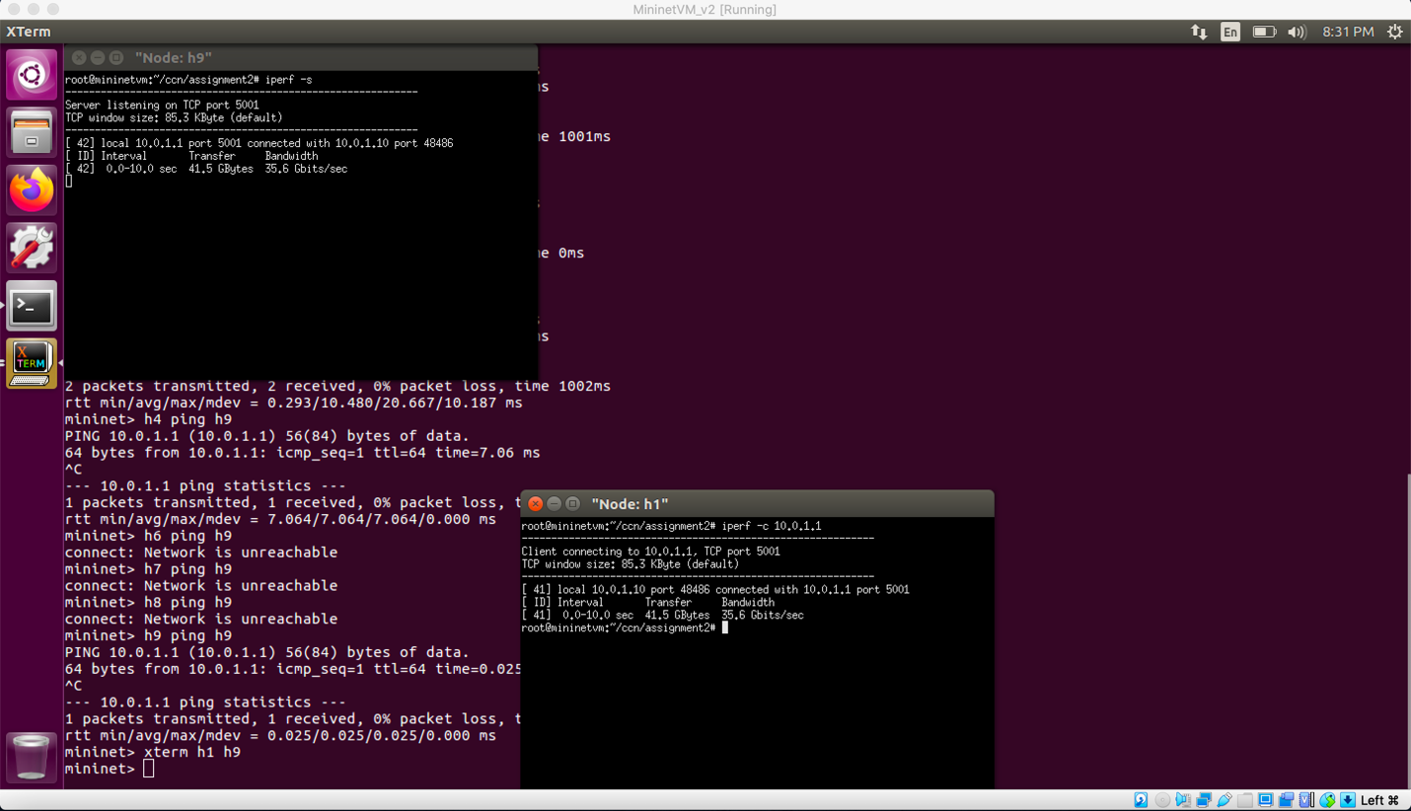

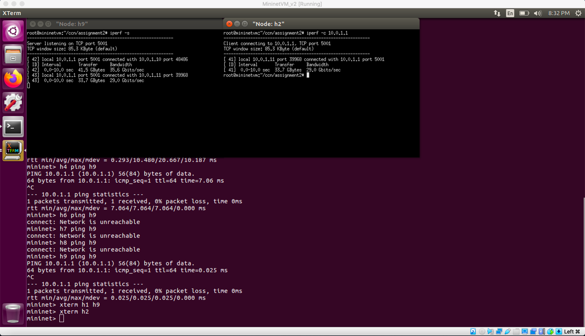

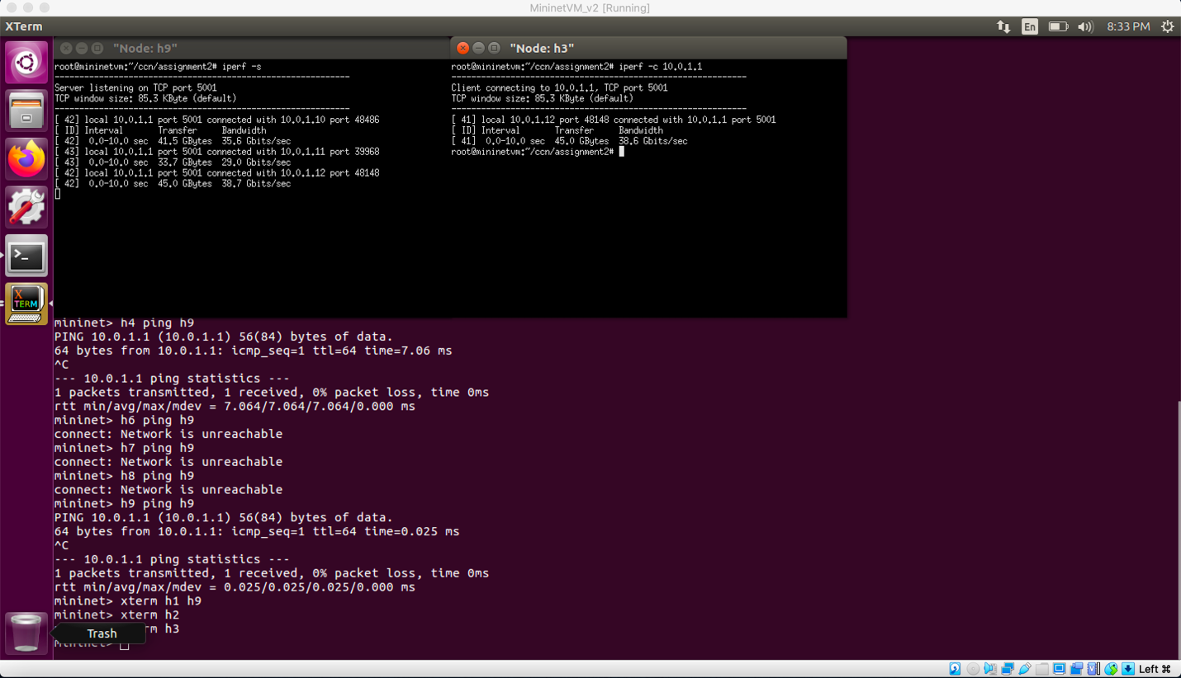

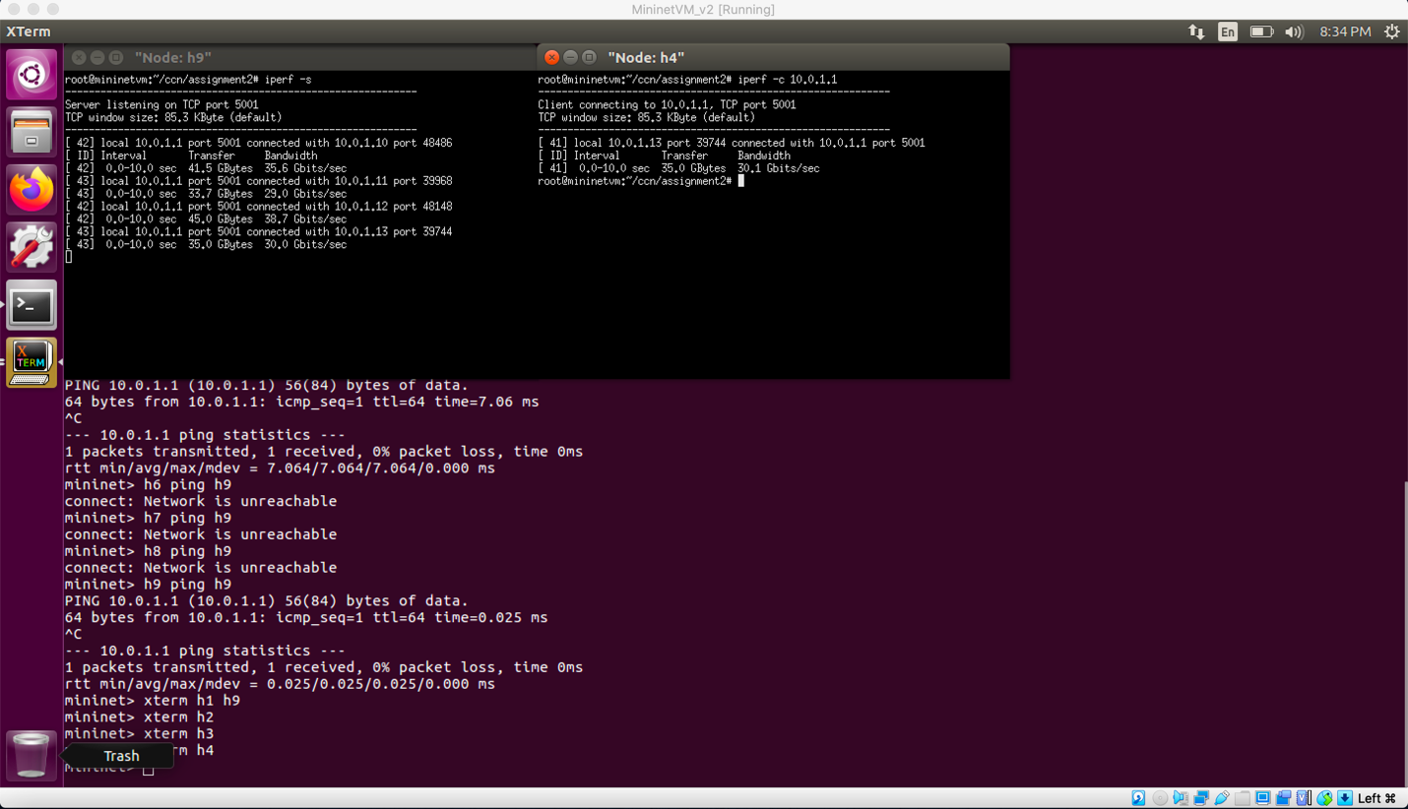

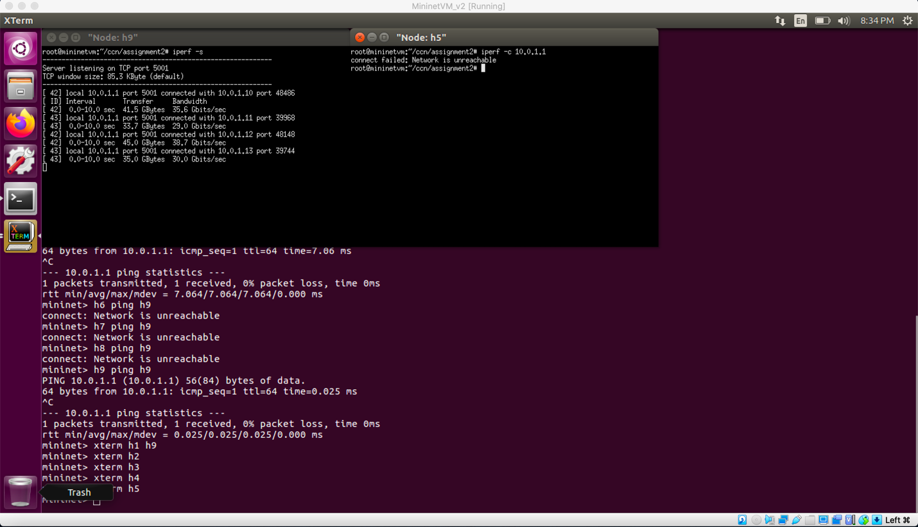

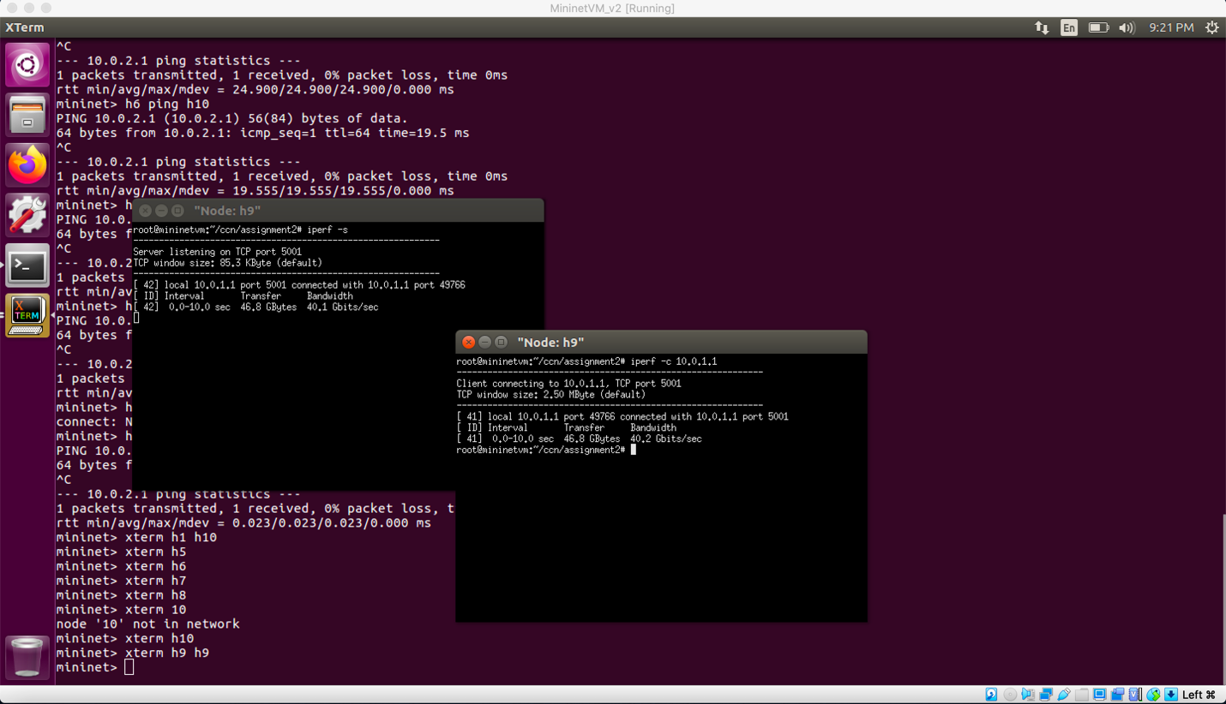

**Measure of Bandwidth and Delay (h1, h2 … h10 on h10)**

**Delay Calculation**

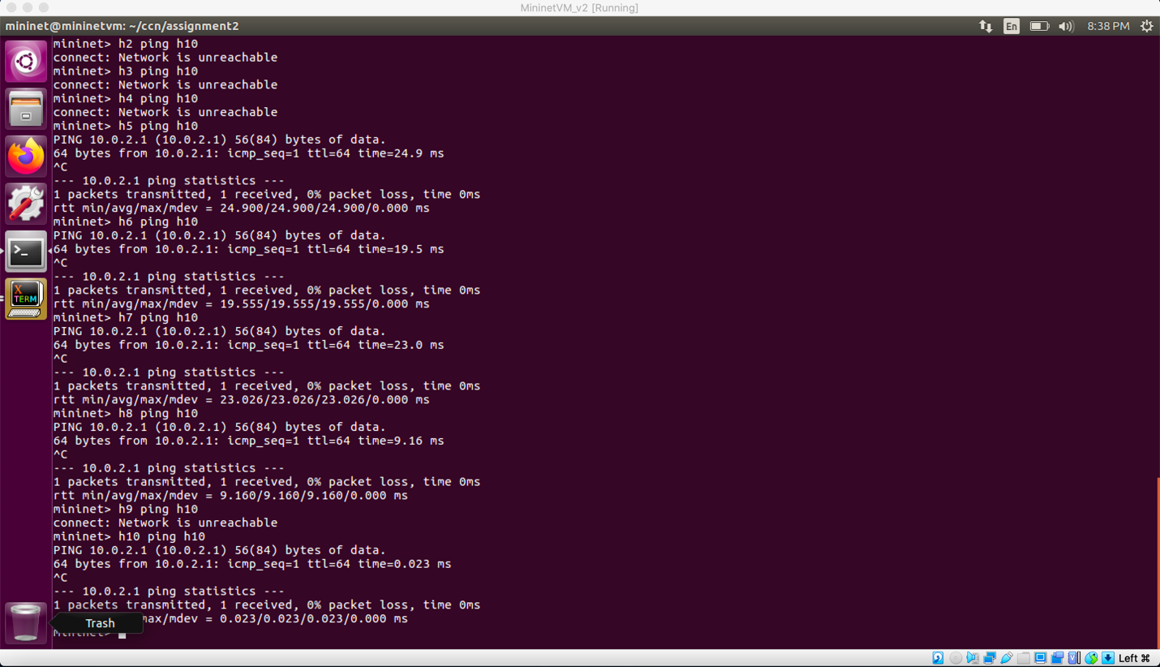

**Bandwidth**

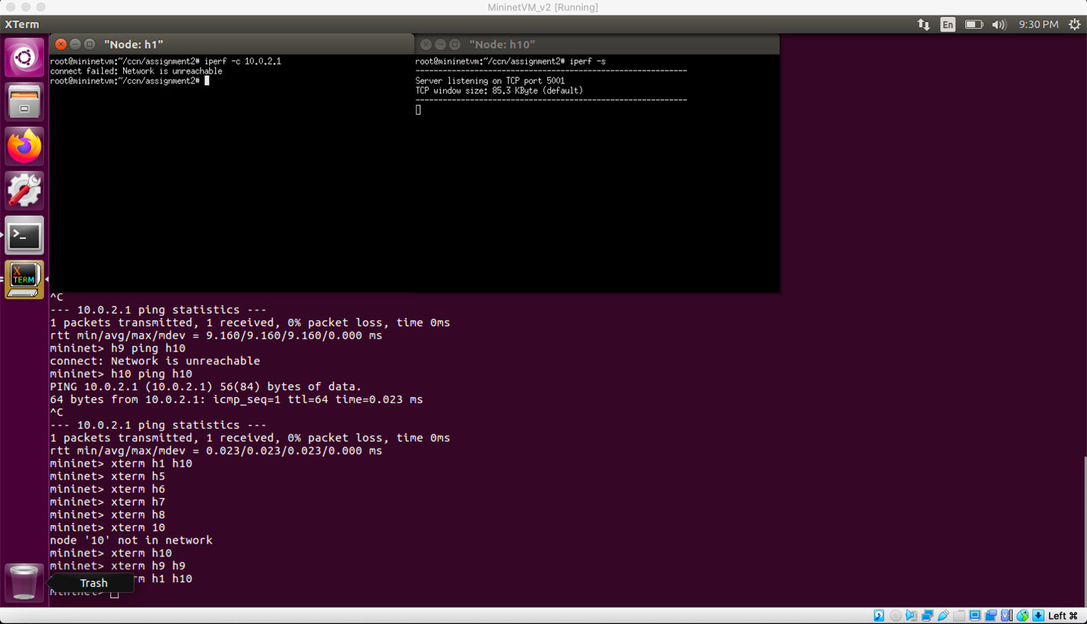

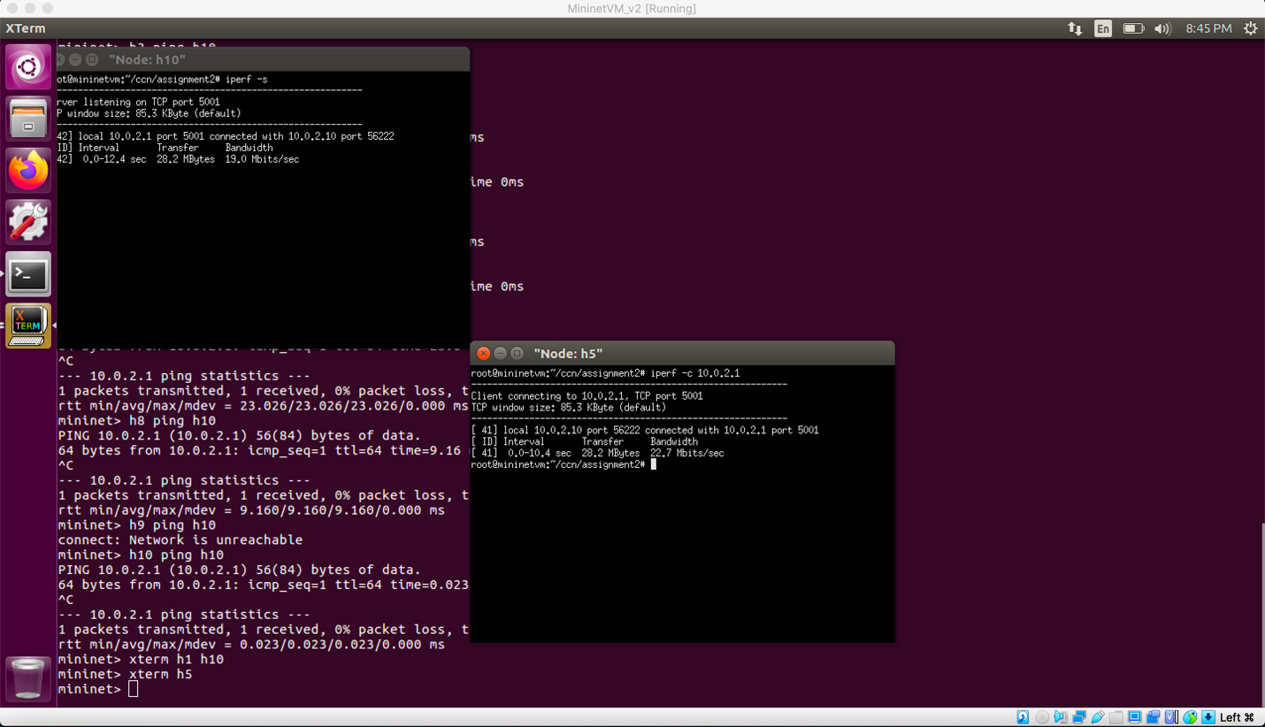

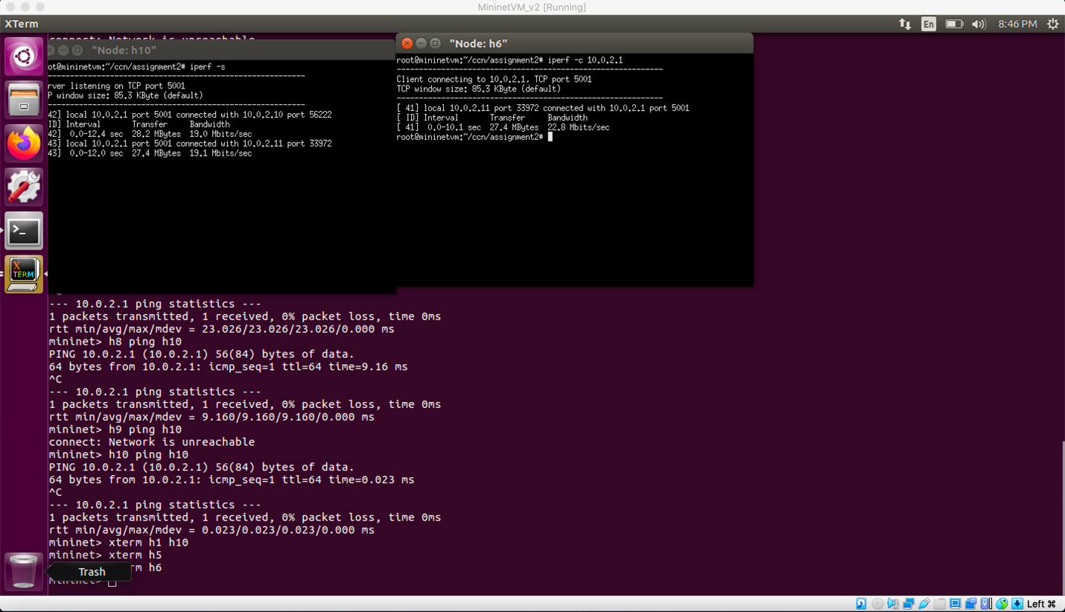

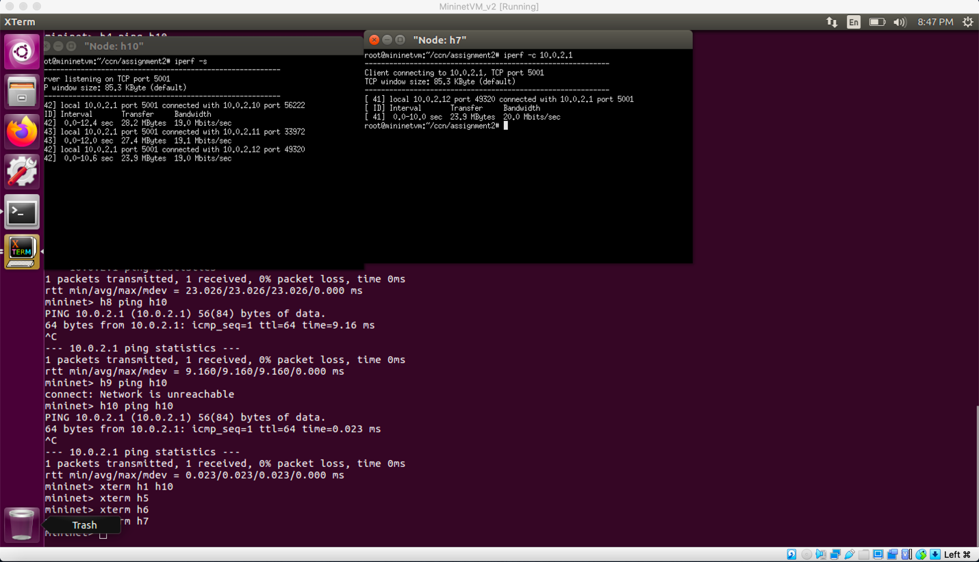

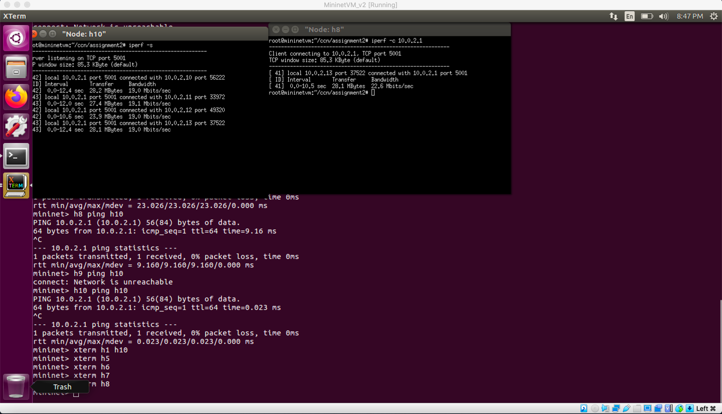

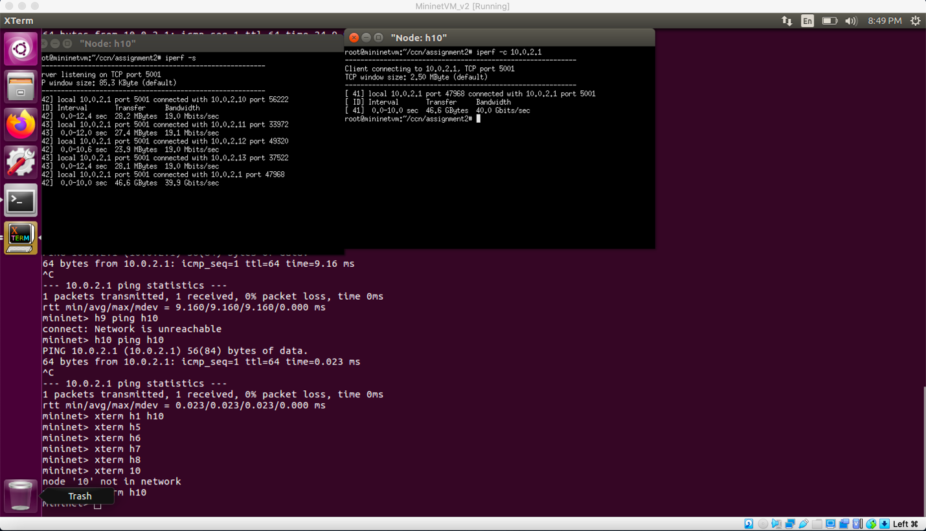

**Why same node are not reachable?**

The host h9 network is 10.0.1.1 and network of h10 is 10.0.2.1. Both h9 and h10 belong to different network. H1, h2, h3, h4, h9 are connected to the same network and h10, h5, h6, h7, h8 are connected to the same network but both the network grp differs from each other. They are configured using subnet mask 255.255.255.0. since there are no routers these two networks cannot communicate with each other.